**Geocoding Guide**

This guide describes the steps for geocoding addresses using ArcGIS. Geocoding is the process of matching an address to a location. For the purposes of shelter analysis, this involves matching addresses, including those with typos or errors, to geographic coordinates (latitude and longitude). Once the geographic coordinates for a record are assigned, other geographic data can then be attributed to that record, such as median household income, land use classification, or human population density. Full documentation for ArcGIS geocoding can be found with these links:

[ArcMap](https://desktop.arcgis.com/en/arcmap/10.3/guide-books/geocoding/geocoding-a-table-of-addresses-in-arcmap.htm)

[ArcGIS Pro](https://pro.arcgis.com/en/pro-app/latest/help/data/geocoding/tutorial-geocode-a-table-of-addresses.htm)

[ArcGIS Online](https://doc.arcgis.com/en/arcgis-online/reference/geocode.htm)

Geocoding can be done in a variety of applications ranging from paid services to open-source software. [Texas A&M has compiled a list of software providers](https://geoservices.tamu.edu/Services/Geocode/OtherGeocoders/) that you can look through to determine which application will best meet the needs of your project.

**Creating a Locator View in AGOL**

If you want to specify your address search to a certain area or region, you can create a Locator view to specify the area/types of locations that you are interested in. Creating your own locator can help identify incomplete addresses with higher confidence by limiting the search area.

1. In ArcGIS Online, go to the Content tab, select “Create”, select “Locator (view)”, and enter a descriptive name and relevant tags.
2. When prompted by the question: “What types of locations do you want to find?”, select your preference based on the types of addresses/locations that you are working with. Selecting “All Types” is recommended if you are working with multiple different types of addresses.
3. When answering the question “Where do you want to search for locations?”, select the option that fits best for the addresses that you are working with. If choosing “Within a selected area”, click “set area” and draw a box around the area that you want to search for addresses within.
4. You may need administrator approval to add your locator to the address locator options in ArcMap.

**Geocoding in ArcMap**

1. Click and drag the desired CSV file into ArcMap
2. Your file will appear in your Layers – right click on this and select “**Geocode Addresses**”

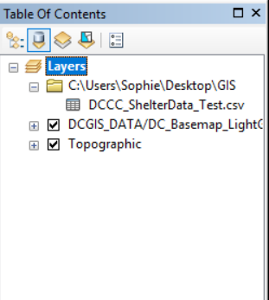

1. A window will open that will prompt you to select an address locator. Either select “ArcGIS World Geocoding Service” or your own Locator View (instructions above), based on your preferences and the level of detail of your addresses (for example, if your addresses are complete with city, state, and zip code, then using the world locator will be successful; if your addresses are not complete, or are lacking certain descriptors, then using your own locator will be advantageous). Select an option and click “OK”.

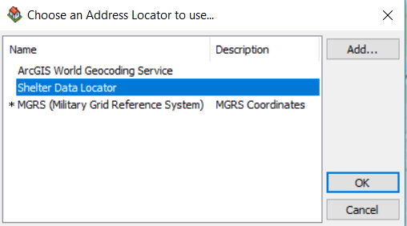

1. The address table that you imported will already be selected; if you wish to use a different CSV file, you can click the folder icon next to the “Address table” dropdown menu. Depending on how the addresses are listed in your file:
2. If the full address is listed in one cell:
   * Select “Single Field”, and under “Single Line Output”, use the dropdown menu to select the name of the column that contains the address
3. If different components of the address are listed in multiple cells:
   * Select “Multiple Fields” and select the relevant column in the dropdown menu for each option. If one of the fields is not applicable, just leave it as “<none>”.

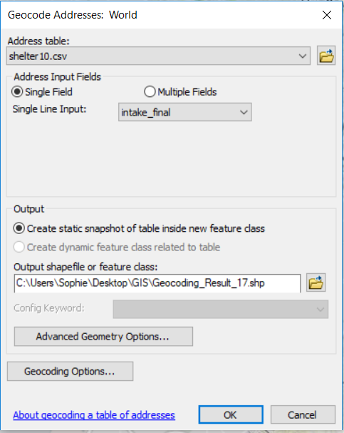 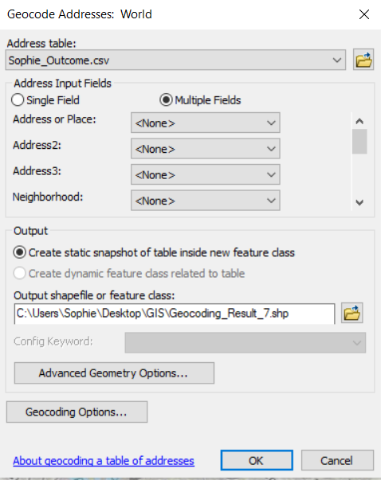

1. Click on “**Geocoding Options…**” at the bottom left of the window. The “Minimum candidate score” and “Minimum match score” will both be set to 60 by default. You can increase either or both of these by clicking and dragging on the bar, or by manually entering the desired number in the text box. For example, increasing the minimum match score to 95 will prevent the geocoding tool from making any matches that are below 95% confidence, allowing for easier manual sorting of addresses that are below this confidence. Click “**OK**” to save your preferences.

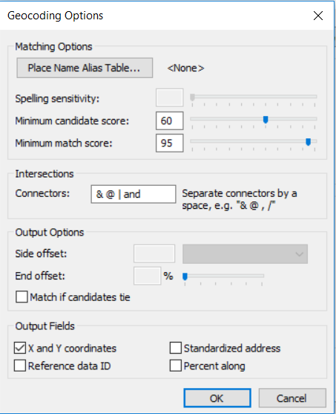

1. 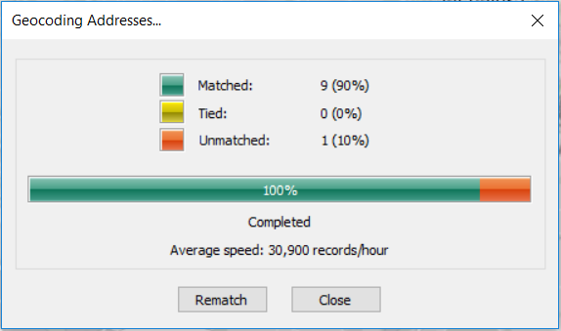Click “OK” on the original window to begin geocoding your selected addresses. This may take several minutes for a larger dataset. When it has completed running the addresses, a screen will pop up indicating the percentages of addresses in Matched, Tied, and Unmatched Categories. Click “**Rematch**” to manually review the addresses.
2. 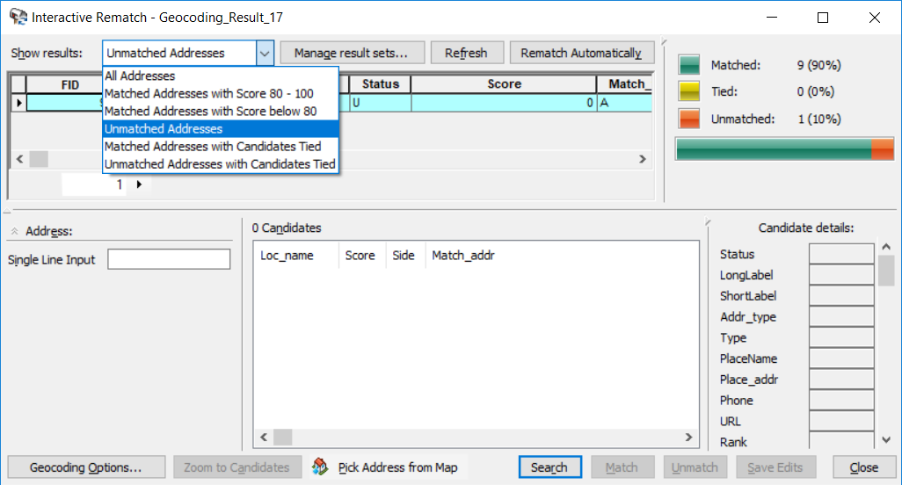An Interactive Rematch window will appear. In the “Show results:” dropdown menu, you can select which addresses to filter for review. Reviewing all addresses under 95% confidence is encouraged, but carefully reviewing unmatched addresses and addresses with candidates tied is highly recommended in order to catch mistakes or manually create matches, if applicable.
3. If you catch a spelling error or missing information in an address input that prevents a match, you can manually alter the input in the “**Single Line Input**” box. Hit enter, and new candidates or match options will appear. You can then click on the desired match, and click “**Match**” to manually match it. Alternatively, if it incorrectly matches something, you can click “**Unmatch**”. When creating or removing matches, the “Matched”, “Tied” and “Unmatched” graphic at the top right of the window will automatically update.

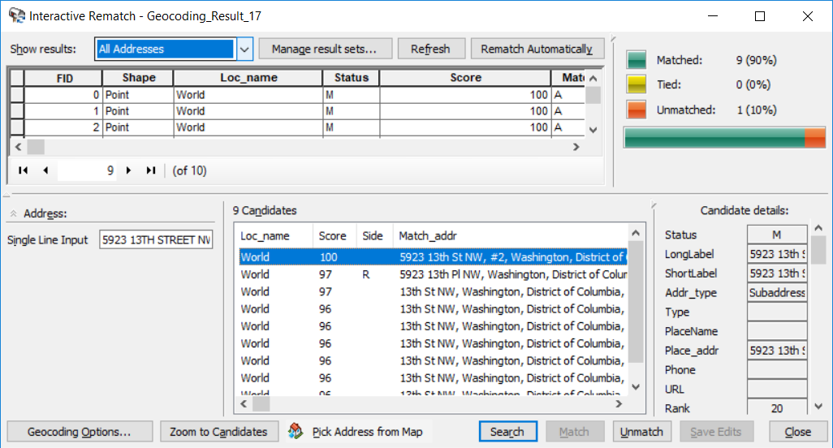

1. When you are finished reviewing, hit close. Your geocoding result will appear as a new layer. You can edit the shape/color of the symbols by double clicking on the symbol as it appears in the layer.

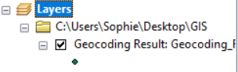

1. Go to “**Customize**” > “**Toolbars**” > “**Geocoding**” to get the geocoding toolbar to appear. If you single click on your geocoding result in your layers, you can select the “Review/Rematch Addresses” icon to re-open the matching window.

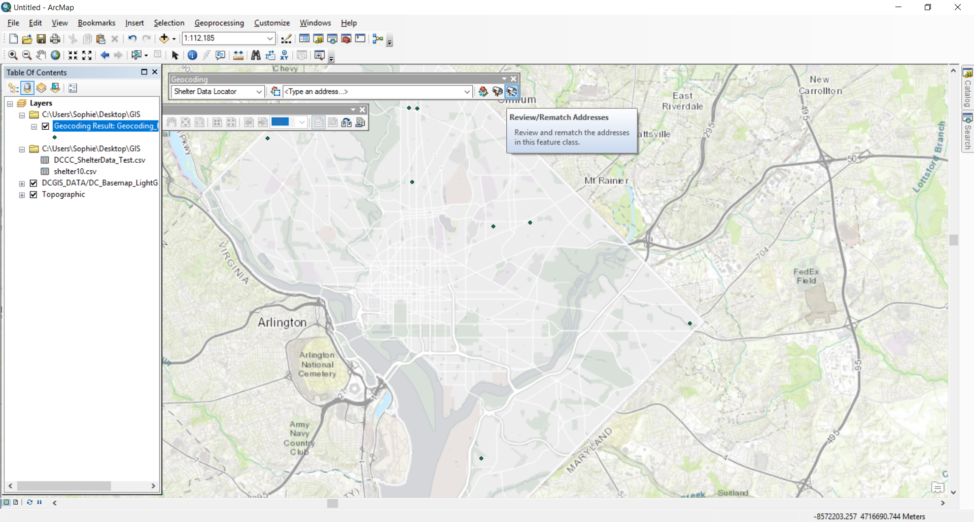

1. The geocoding result automatically saves in your respective GIS folder. If you want to reopen one or multiple geocoding results, you can simply click and drag the layer from your folder in the Catalog toolbar.